Step 2 Came to believe that a power greater than ourselves could restore us to sanity

2.4 Came to Believe

“SAA is not affiliated with any religion, creed or dogma.” Sex Addicts Anonymous 1st ed. Pg 21

The 12 steps promise only one thing, a spiritual awakening, which we fully realize in Step 12. They do not promise anything about marriage, financial security, health, or peace of mind. They do not guarantee freedom from addiction but do offer hope. They promise a spiritual awakening. Many start to become aware of that spiritual awakening here in Step Two.

Many of our efforts to stop addiction had failed. We needed to use another way: working the 12 Steps. Step Two is the first act of that new way: a different way of dealing with the problems of life.

Step Two offers hope: that a power outside of ourselves can restore us to sanity. That sanity includes the possibility of never acting our again; of living life free from the addiction.

Many of us try to put the words of this step in context with what we experienced before. We react to the words “believe”, “higher power”, and “restore us to sanity” with either minimization or rejection. Some think they have completed this step because they have been very religious. Some think that they can’t do it because they are not religious. Some people have not major reaction at all. (Page 26 in the Green Gook has more on these various reactions.)

What is my initial reaction to the words of this step?

Because Step Two is about hope and belief, there are no “actions” involved in working the step. But working Step Two always generates actions and changes in behavior. Hope requires actions when wishes do not. We can wish to win the lottery, but until we take action to buy a ticket, we have no hope of winning. When we have hope, we search for the object of that hope. When we first have hope that this program could help us in our addiction, we wrote from our prison cell, we went online to search for how to contact the program, we came to our first meeting, we called in to our first tele-meeting, and we asked for a sponsor.

What actions have I already taken looking for the hope that there is recovery from this addiction?

(We have found that some people have a particularly difficult time with this step. Here is some extra material for the person whose basic approach has been academic and for the person who is religiously trained.)

The phrase, “came to believe”, is not about religion, but has to do with how we deal with troubles, struggles, and events in our lives.

When we look at how we handle problems in our lives, most of us can find that we have existing, and often unconscious, addictive beliefs that drive our choices. No matter where we stand on religious matters, we had an unconscious belief system centered around our addiction.

After we first encountered sex, we returned to it over and over again and found that it helped us cope. As we continued to seek out sex, our experiences and unconscious reactions were woven into an addictive belief system.

We kept acting on those beliefs when faced with stresses and difficulties by using sex. That left us with more shame and more stress, which fed right back into that system and strengthened those beliefs.

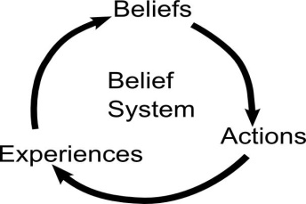

We can become aware of these addictive beliefs when we take an honest look at our actions. One such belief is that “I have to handle it all by myself.”

How do I react when I am under stress, have a problem, or when doing something that I have never done before?

Do I ask for help or try to handle it myself?

What are my reactions when asking for help?

Part of these beliefs come from early on. Many of us have histories of abuse or neglect which taught us that nobody would listen or care or help us without demanding “payment” in return. We do not trust anyone.

Growing up, what happened when I asked for help?

When I share in group, do I feel that people listen and care?

What are my experiences with sharing in group?

When we take actions of hope, there is often a reaction that may return us to our addiction. We want to go back to our old practices. We have internal reactions such as shame, and relief. Family and others might resist our recovery. We
fall back to our old beliefs that are the foundation of our addiction.

How have I wanted to go back to my addiction?

What reactions did I have to coming to my first meeting?

What resistance did I experience from family and others?

When we look honestly at our actions, we may see other beliefs that we are acting on. We may have multiple, conflicting beliefs acting in our lives. Any number of other beliefs may conflict with the coming to believe” in this step and prevent us from taking the actions of hope. Here are some common beliefs:

- My most important need is sex
- Even though I want love and compassion, the only way to meet those needs is through sex.
- People who ask for help are weak
- Nobody is going to listen to me
- If I call someone in the program, they will be too busy to talk to me. I will be an unwanted interruption.
- I can’t count on anyone else. Nobody cares about me or my pain
- If I express a need, you will get angry at me.
- I’m afraid of what would happen to me if I am vulnerable.
- I’m not worthy of anybody’s consideration.
- Even though I need you, you are going to leave me.
- If you knew who I really was, you wouldn’t love me.
- Inherently, I’m a “bad” person and I have to have a mask so that people will like me.
- If I act real religious, people won’t see how little I trust God to take care of me.
- God is too busy to listen to me or care for me.
- If God exists, God is cruel and will punish me harshly
- The majority around me has a religious belief that I cannot conform to.

Which beliefs have been active in my life?

What other reasons have you come up with as to why you cannot work a recovery program?

When we have hope, we show this hope in our actions. Here are some actions people have used to express their hope that a power outside of themselves could restore them to sanity:

- Saying in a meeting what I did in the last acting out.
- Be able to call right after acting out or go to a meeting and say it.
- Calling one step before acting out when we know we will lose everything if we do act out.
- Getting a sponsor
- Telling my story to the group (giving my “first step”).
- Calling someone in the program on a regular basis.

Which actions would I be able to do in my situation?

We “come to believe” when we keep searching for the object of our hope even if we do not find it at first. We keep on searching for recovery even when we do not get sober in our first meeting. We keep on trying to contact people in our group even when the first person doesn’t reply. We keep on working the steps even when we do not get recovery by working only Step One.

How have I continued my search for the hope of recovery in Step Two?

We show what we believe by what we do. To “come to believe”, we take different actions without the assurance that these actions will work.
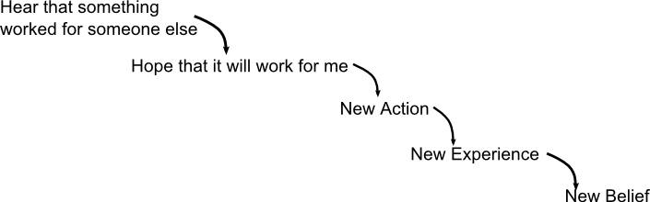

In recovery, we step out of our prior experiences and act in new ways. As we listen to what works for others, we gain the hope that the same might work for us.

We take new actions, see that those actions do work for us, and we start to believe.

